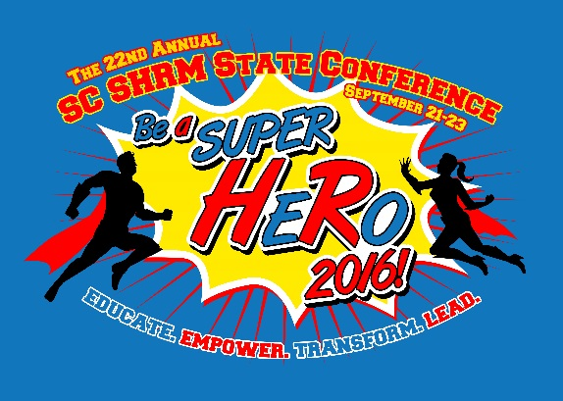
2016 SC SHRM Academy
Wednesday, September 21, 2016

NOTE: The 2016 SC SHRM ACADEMY is a pre-conference workshop. A separate fee is required to attend these sessions. You may register for the sessions on the Conference Registration page here. This year we are offering two half-day sessions as a part of SC SHRM Academy. Register for only one ($250 each) or save money by registering for both ($350 for both). There is also an early bird discount of $25 if you register prior to August 14, 2016. The courses have been approved for 7.5 hours of SHRM Professional Development Credits (PDCs). HRCI Business Credits have also been applied for.
MORNING SESSION: 8:00 a.m. – 12:00 noon
“Leadership Impact During Crisis – Your Role Beyond HR”
by Shawn Edwards, SHRM-SCP, SPHR

“Shots fired…” In today’s world, the instance of crisis within organizations or within the communities in which organizations exist is high. Human Resource Executives need to be prepared and ready to create and implement strategies for situations that are virtually unthinkable. This workshop will help participants consider organizational factors from a high level to begin building a strategy that could serve as their framework when the crisis strikes. The strategy development allows them an opportunity to have leadership impact during crisis and a role beyond human resources. This type of forethought positions the HR Professional to be the HR Executive.
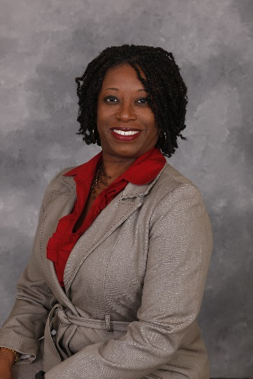
Shawn Spann Edwards, SHRM-SPC, SPHR is the Chief Diversity Officer for The Citadel, The Military College of South Carolina and is responsible for the diversity, inclusion and equity efforts and programs for the institution. Additionally, Shawn serves as adjunct faculty at The Citadel, Trident Technical College, Virginia College and the College of Charleston. Shawn holds an Associate of Arts in Fashion Merchandising from Bauder College, a Bachelor of Arts in Management from Webster University, both an MBA with a Human Resource Management concentration and a Graduate Certificate in College Teaching and Learning from Walden University. Shawn currently serves as a board member for the SC Society for Human Resource Management (SC SHRM) and an Advisory Board member for Trident United Way’s African American Leadership Council and Palmetto Warrior Connection. Most recently, Shawn was recognized as one of the Charleston Regional Business Journal’s 2015 Forty Under 40 and is a graduate of the 2016 Class of Leadership South Carolina.
AFTERNOON SESSION – 1:00 p.m. – 4:30 p.m.
“CRASE – Civilian Response to Active Shooter Events”
By Capt. Joe Stephens and Lt. Victor Buskirk

How can your organization prepare in advance for an unwanted intruder threatening deadly force? The CRASE program is built on the Avoid-Deny-Defend strategy and developed by Advanced Law Enforcement Rapid Response Training (ALERRT). From the 1966 Tower shooting at the University of Texas, to the coordinated terrorist attacks in Mumbai, India in 2008, to the Fort Hood shooting in 2009 and beyond, the best lesson learned is to be prepared. While we hope that such active shooter events will never happen in our backyards, the ALERRT staff at Texas State University has developed a new standard in active shooter response and law enforcement professionals across the nation are carrying this standard forward. The lesson plan provides strategies, guidance and a proven plan for surviving an active shooter event. Topics include Disaster Response Psychology, History of Active Shooter Events (ASE), and Civilian Response to ASE which is based on the Avoid-Deny-Defend strategies.

OUR PRESENTERS:
Captain Joe Stephens has been with the North Charleston Police Department for 23 years with over half of that time in the Special Operations Division. He was an active S.W.A.T. Operative for fourteen years and the Emergency Response Unit Tactical Commander from 2007 until 2014. A certified Basic Instructor through the South Carolina Criminal Justice Academy; he is also an Active Shooter Response Instructor, a CRASE (Civilian Response to Active Shooter Events) through A.L.E.R.R.T. as well as being certified in numerous other programs related to Law Enforcement. He is currently assigned to the Central Bureau as a supervisor within the Uniform Patrol Division.

Lieutenant Victor Buskirk has been with the North Charleston Police Department for 16 years with time in the Special Operations Division, Patrol Division and Investigations Division. He is an active Mobile Field Force Squad Leader and has been assigned to the team for over 8 years. Lt. Buskirk is a certified Basic Instructor through the South Carolina Criminal Justice Academy and specializes as an Active Shooter Response Instructor for law enforcement. He is a member of the South Carolina Advanced Active Shooter Counter Asymmetric Training group. His most appreciated certification is CRASE (Civilian Response to Active Shooter Events) through A.L.E.R.R.T. Lt. Buskirk is currently assigned to the Investigations Division as a supervisor within the Community Investigative Services Section.
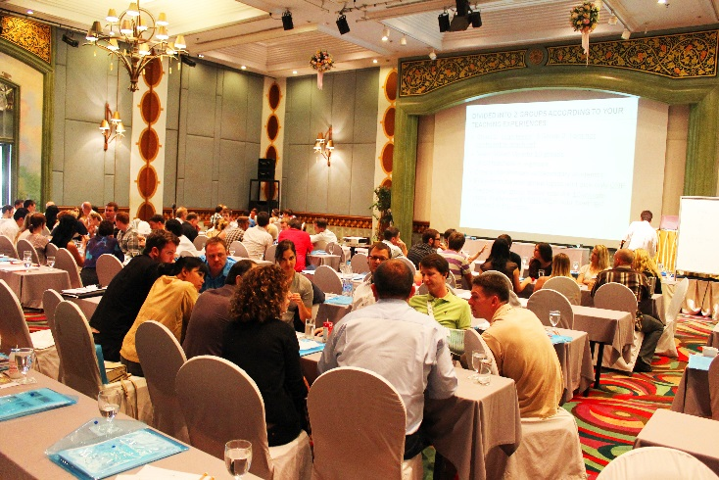
2016 SC SHRM Academy
Wednesday, September 21, 2016

Educate.
Empower.
Transform.
Lead.

To Register: Click here.

