South Carolina Society for Human Resource Management
2016 State Conference
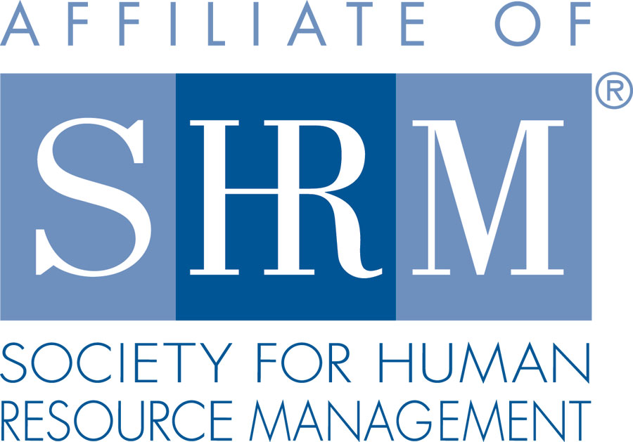

Presenting Sponsor:

Exhibitor/Sponsorship Opportunities
The Marriott Resort & Spa at Grande Dunes, Myrtle Beach, SC
September 21 – 23, 2016

Presenting Sponsor $7000
First booth location choice – larger booth (see other details: Exhibitor Booth A)
2 minute company presentation at kickoff
1 minute company presentation at SC SHRM Strategic Academy
SOLD
Named presenting sponsorship on all pre-registration materials
Company signage at entrance to exhibitor hall
Placement on website registration link
Website Sponsorship
Company literature in conference bag (must be received by August 1)
2 additional seats (4 total) for Thursday lunch with the attendees
4 networking night tickets

Platinum Sponsor at $2500 (three available)
Exhibitor Booth (see details under Exhibitor Booth A)
Prime booth location
Recognition in printed materials at the conference
Sponsor’s message to a group during a session (2 minutes)
Company signage in registration/exhibitor area
Website Sponsorship
Company literature in the conference bag (must be received by August 1)
2 Networking Night Tickets

Keynote Speaker Sponsor at $1400 (three available)
Exhibitor Booth (see details under Exhibitor Booth A)
Sponsor’s message during a session (1 minute)
Display/distribute material at the session
Company signage at the session
Website Sponsorship
1 Networking Night Ticket

SC SHRM Strategic Academy Sponsor at $1200 (three available) September 20, 2016
Exhibitor Booth (see details under Exhibitor Booth A)
Sponsor’s message during day of the Academy (1 minute)
Company signage at the Academy
Recognition in printed materials at the conference
Distribute material during the event
2 seats for lunch with the attendees during Academy

Networking Night Sponsor at $1200 (three available)
Exhibitor Booth (see details under Exhibitor Booth A)
Sponsor’s Message to Group
Company signage at the dinner
Website Sponsorship
Four tickets to Networking Night ($240 value)

Welcome Reception Sponsor at $1200 (three available)
Exhibitor Booth (see details under Exhibitor Booth A)
Sponsor’s message at reception (1 minute)
Display/distribute material at the reception
Company signage at the reception
Website Sponsorship

Thursday Lunch Sponsor at $1200 (three available)
Exhibitor Booth (see details under Exhibitor Booth A)
Sponsor’s message to group at luncheon (1 minute)
Display/distribute literature during event
Company signage at the lunch
Website Sponsorship

WEBSITE SPONSORSHIP – included in Sponsorships - Add on to BOOTH for $150
Stand-Alone for $350 (no early bird discount)
Your company logo on our SC SHRM website with Home Page link
This will be posted after payment is received and remain on the site until April 1, 2017

EXHIBITOR BOOTH (60 available) 10’ wide x 6’ deep*

Exhibitor Booth A at $725 per booth
Six foot skirted table and two chairs in the vendor area*
ID Sign on Booth
Name and contact info in exhibitor listing on SC SHRM website
List of attendees and mailing addresses
2 seats for Thursday lunch with the attendees
DOES NOT INCLUDE NETWORKING NIGHT TICKETS (available for purchase)

Exhibitor Booth B at $785 per booth
Exhibitor Booth (see details under Exhibitor Booth A)
INCLUDES ONE NETWORKING NIGHT TICKET (additional tickets available for purchase)

Exhibitor Booth C at $845 per booth
Exhibitor Booth (see details under Exhibitor Booth A)
INCLUDES TWO NETWORKING NIGHT TICKETS (additional tickets available for purchase)

*Additional Equipment available for rent through Convention Makers. Order form will be provided.

All sponsors/exhibitors will receive recognition in the HR Partner Sponsor/Exhibitor Listing which will be received by each conference attendee. Each will also receive a listing of all registered attendees and mailing addresses IN ADVANCE of the conference.

Receive a $50 DISCOUNT on your booth or sponsorship by sending in your PAID registration by July 1.

To become an exhibitor and/or sponsor, to register and pay online click below:

or follow this link

http://events.constantcontact.com/register/event?llr=qrivt9cab&oeidk=a07eciovg642c09fa76

To insure that a sponsorship opportunity is still available prior to making payment,
please contact karen smith at ksmith@gpsjobs.net or 803-744-3311 or 803-315-1480.

Remember, booths and sponsorships cannot be officially reserved until payment has been received.

Exhibitors often ask if purchasing a booth means that they are registered for the conference. You are registered as an exhibitor and may occasionally drop in to hear a speaker when the exhibit hall is not open. If you have associates who plan to attend most of the conference seminars or who are not working your booth, we ask that you please register these associates as attendees through the attendee registration process.

The 2015 Conference Theme is “Be a Super HeRo 2016”
To make this event more fun and bring people by to visit, please decorate your booth in participation with the theme.

